**Home Security using GSM**

Safety and security of your home is utmost important because ‘Home is where Heart is’. You are not only worried about material things in your house but you are also emotionally attached to it. You would remember how your first birthday was celebrated, how you studied through the night for exams, how you partied through the night in vacations with friends. These moments cannot be weighed in monetary terms. So, you would like to keep home as safe as possible.

So, let us study how can security of home can be assured in case of flooding, fire breakout, gas leakage or an intruder attacking your home. Our objective of this project is to design & develop a circuit by which security of the home can be assured.

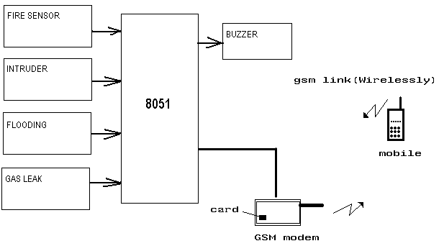

Block Diagram

The figure above shows the four types of threat on security that can occur to your home. In this project different sensors will be used along with microcontroller. Infrared Transmitter & Receiver will be used to detect intruder. LPG sensor will be used to detect the gas leak as well as smoke. Probes will be used to detect the flooding situation.

GSM modem will be interfaced with microcontroller. Whenever any of the listed levels of security is compromised, then buzzer will turn ON & at the same time sms will be sent to the house owner’s mobile that is registered on the GSM modem. Kiel software will be used for programming the microcontroller.

So, this simple circuit can help you to keep your home safe as possible and is not very costly. So, it should be used by everyone to keep home safe and secure.